**TASK 13**

**READ AND WRITE OPERATION OUTPUT:**

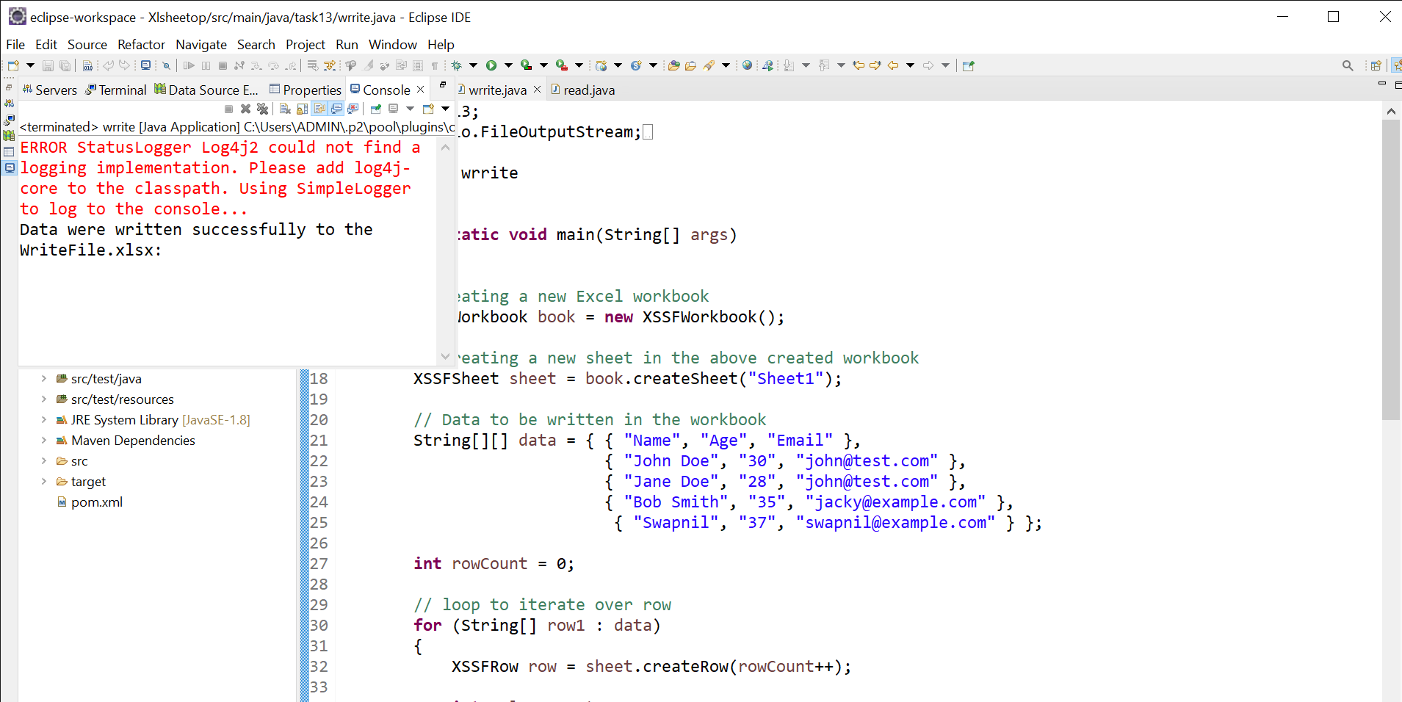

**DATA ADDED IN XLSX SHEET VIA WRITE OPERATION**

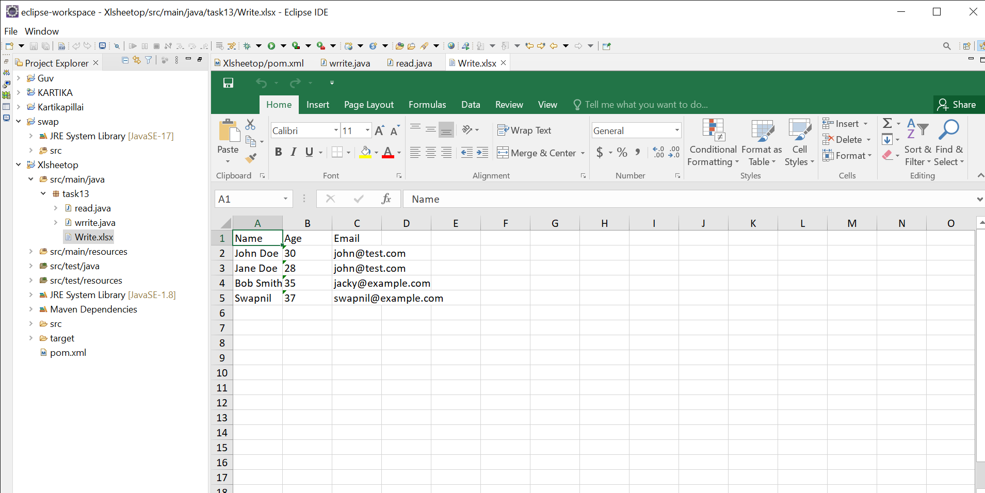

**DATA IS READ USING READ OPERATION**

